Can Learners Make the Jump from the Highest Graded Readers to Ungraded Novels?: Four Case Studies - Schmitt, Uden and Schmitt

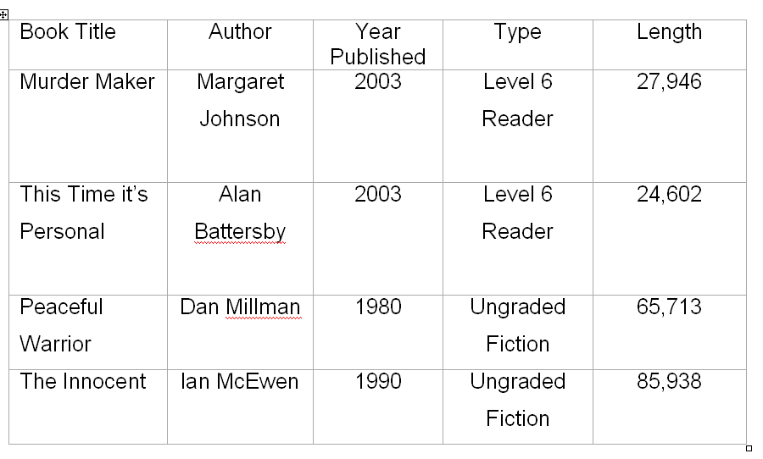

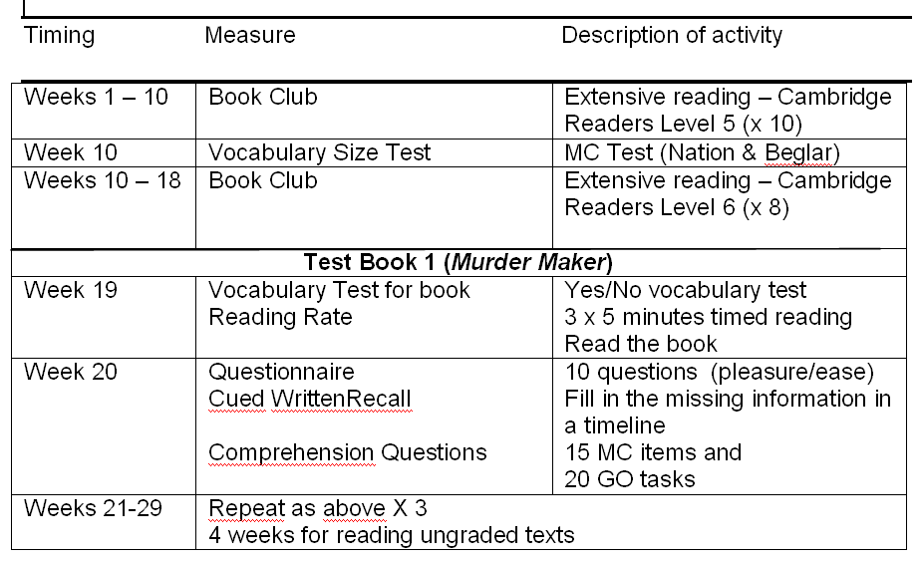
Graphic Organisers

Murder Maker

The information in the reading is organized in the following charts. Complete the charts by filling in 20 blanks. Refer back to the reading if necessary. You may use your own words or words from the text, use complete sentences, phrases, or just key words.

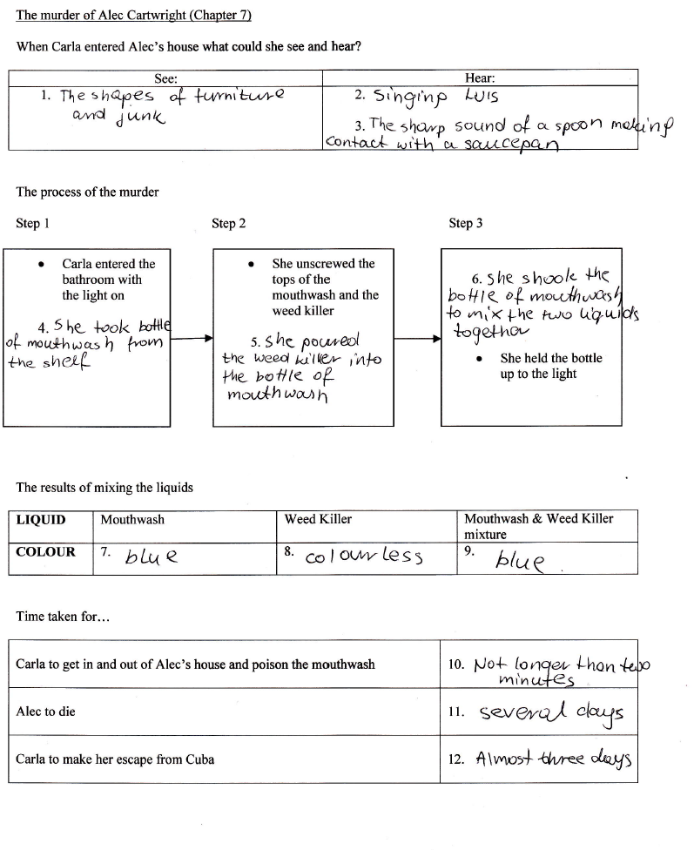

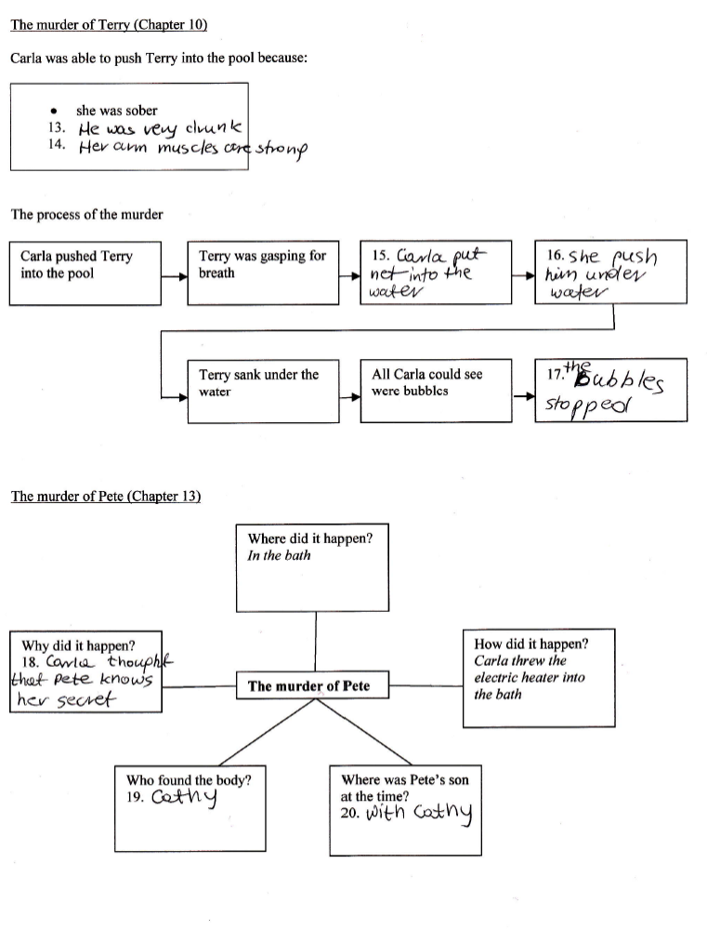

Written Recall

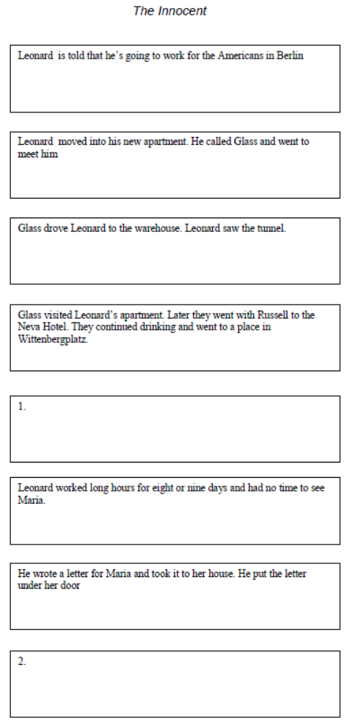

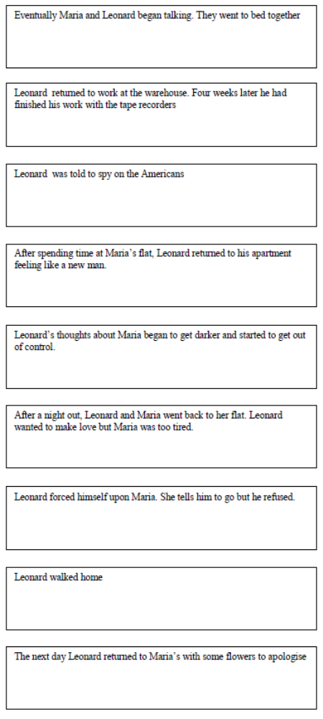
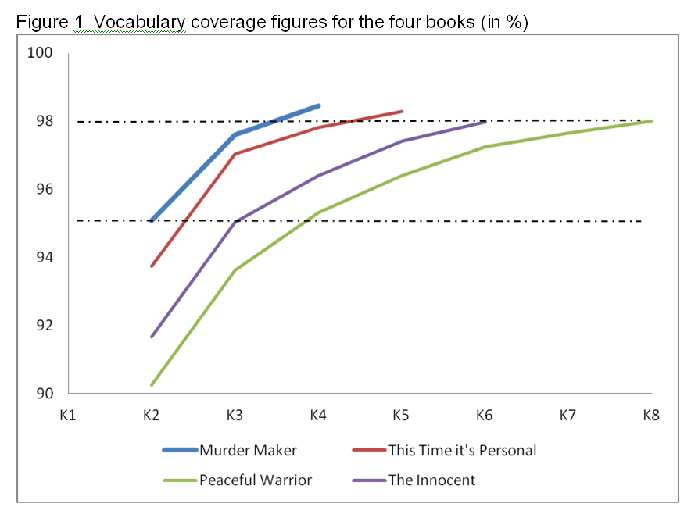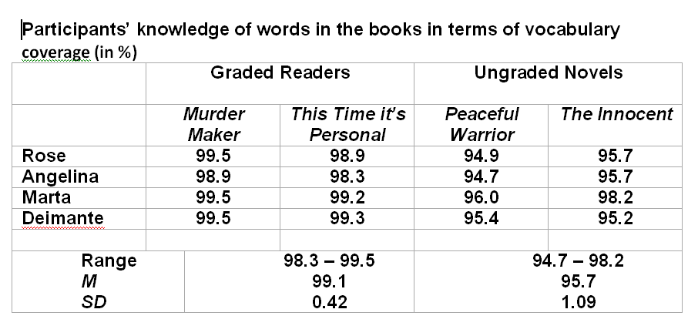

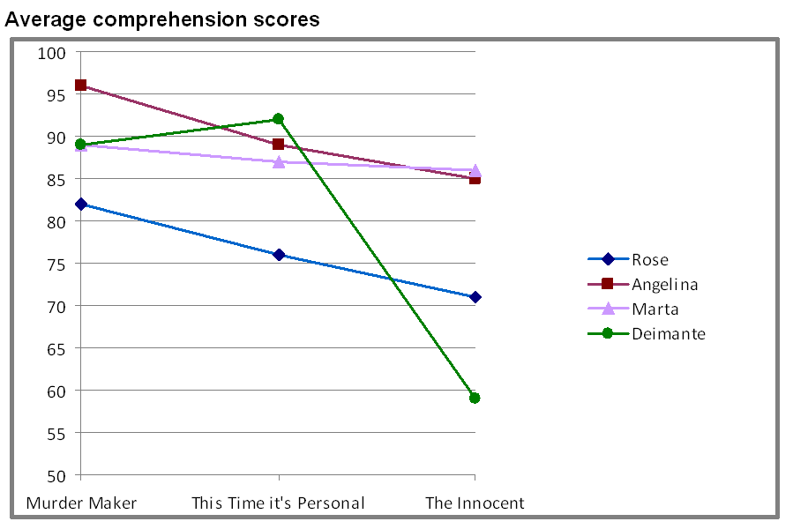

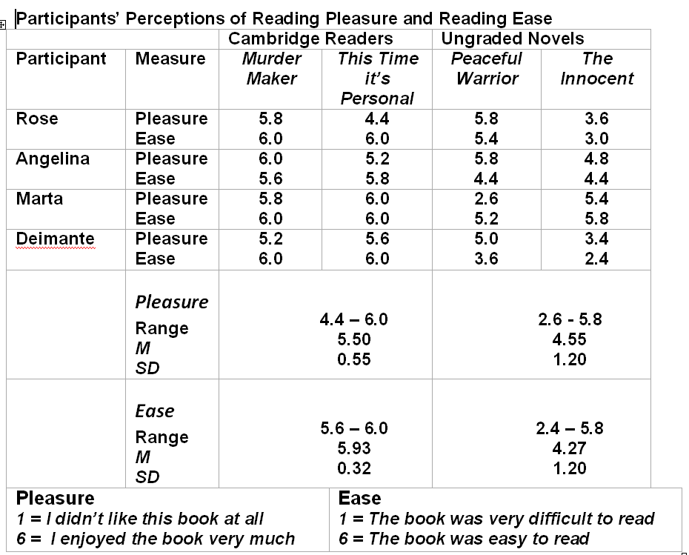
References
Battersby, A. (2003). This time it’s personal. Cambridge: Cambridge University Press.

Honeyfield, J. (1977). Simplification.TESOL Quarterly, 11(4), 431-
440.

Hu, M., & Nation, I.S.P. (2000). Unknown vocabulary density and
readingcomprehension. Reading in a Foreign Language, 13(1), 403-430.

Johnson, M. (2003). Murder maker. Cambridge: Cambridge University Press.

Laufer, B., & Ravenhorst-Kalovski. (2010). Lexical threshold revisited:
Lexical text coverage, learners’ vocabulary size and reading comprehension.Reading in a Foreign Language, 22(1), 15-30.
McEwan, I. (1998). The Innocent.London: Vintage.

Millman, D. (1980). Way of the Peaceful Warrior. California: H J Kramer.

Nation, I.S.P. (2001). A defence of simplification.Prospect, 16(3), 55-67.

Nation, I.S.P. (2006). How large a vocabulary is needed for reading and
listening? Canadian Modern Language Review, 63, 59-82.

Nation, I.S.P. (2009a). Teaching ESL/EFL Reading and Writing.
New York: Routledge

Nation, I.S.P. (2009b). New Roles for L2 Vocabulary. In Cook, V. & Wei, L.
Contemporary Applied Linguistics Language:Vol 1. Teaching and Learning. London: Continuum.

Nation, I.S.P. & Wang, K. (1999).Graded readers and vocabulary.
Reading in a Foreign Language, 12(2), 355-380.

Schmitt, N. (2008). Instructed second language vocabulary learning.
Language Teaching Research, 12(3), 329-363.

Schmitt, N., Jiang, X., & Grabe, W. (2011). The percentage of words
known in a text and reading comprehension. The Modern Language Journal, 95, 26-43.

Waring, R. (2008, December 5). In reply to Paul Nation’s comment on the
gap between graded readers and unsimplified text on The Extensive
Reading Foundation website. Message posted to
http://www.erfoundation.org/erf/blog/16.

